Chapter 241. Subdivision Regulations

Article IV. Conservation Subdivision Regulations

§ 241-12. General regulations.

B.
Standards for conservation subdivisions.
(1)
Density calculation. The maximum density allowed for residential units is calculated by a formula based upon the acreage of unconstrained land on the property.
(a)
To determine unconstrained acreage, subtract from the total or gross acreage of the proposed development parcel, the acreage of constrained land.
(b)
To determine the number of allowable residential units or "base density" on the site, divide the unconstrained acreage by the allowable number of acres per unit required within the zoning district. Round down fractional units of 0.5 or less and round up fractional units greater than 0.5. Figure IV, 1a through Figure IV, 1c illustrates a density calculation on a site in a hypothetical conservation subdivision in an RR District.
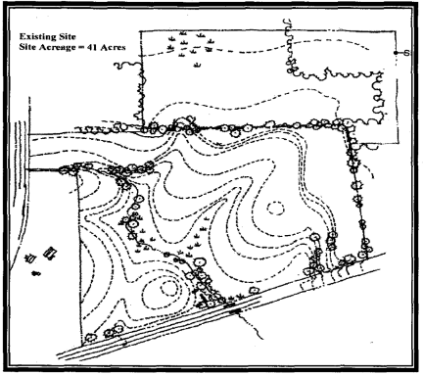
Figure IV, 1a Existing Conditions Site Boundary
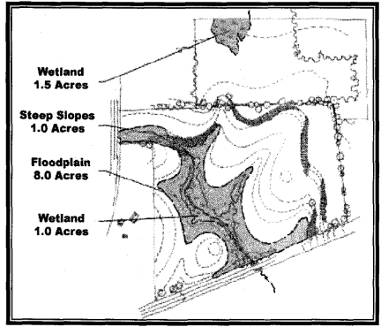
Figure IV, 1b Constrained Land

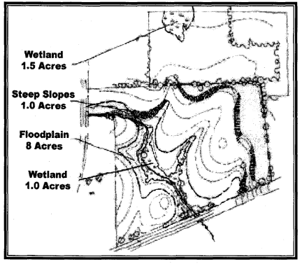
Figure IV, 1c Density Calculation for RR-2 District
 | Total site acreage: | 41.0 acres
 | Constrained acreage:
 | Floodplain: | 8.0 acres
 | Wetlands: | 2.5 acres (1.0 acre overlaps with floodplain)
 | Steep slopes: | 1.0 acre - 10.5 acres
 | Unconstrained acreage: | 30.5 acres
 | Base units allowable: | 30.5 ÷ 2 = 15.25
(c)
The base density in Subsection B(1)(b) may be increased by up to 20% at the sole discretion of the Board if permanent public access will be granted to the protected open space land and any associated improvements as described in Article IV, § 241-12C.
(d)
The density permitted by this section shall not be reduced as a result of the conservation analysis required in Article IV, § 241-12B(2) below, or as a result of the reservation of parkland during the subdivision process.
(2)
Conservation analysis.
(a)
As part of a preliminary subdivision plat application procedure (see Article II, § 241-12C), an applicant shall prepare a conservation analysis, consisting of inventory maps, description of the land, and an analysis of the conservation value of various site features. See Conservation Analysis Checklist in Appendix F.^{[1]} The conservation analysis shall show lands with conservation value, including but not limited to the following:
[1]
Constrained land;
[2]
Open space and recreational resources described in the City's Open Space Plan;
[3]
Buffers to provide an area for installation of screening to obscure and enhance the view of new development from adjoining parcels;
[4]
Land exhibiting present or potential recreational, historic, ecological, agricultural, water resource, scenic or other natural resource value.
[1]
Editor's Note: Said appendix is included at the end of this chapter.
(b)
The conservation analysis shall describe the importance and the current and potential conservation value of all land on the site. In the course of its initial preliminary subdivision plat review, the Board shall indicate to the applicant which of the lands identified as being of conservation value are most important to preserve.
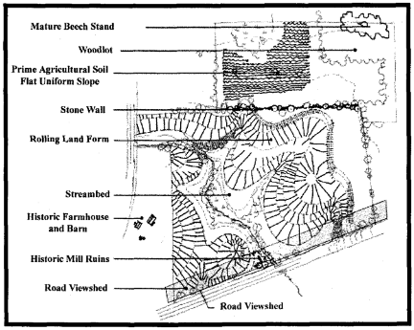
Figure IV, 2a Conservation Analysis: Inventory Map (see also Figure 4.1b)
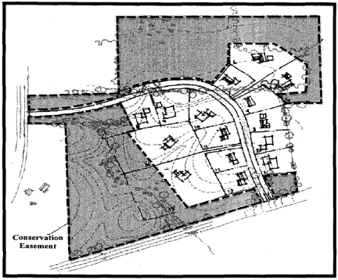
Figure IV, 2b Conservation Analysis: Sample Preliminary Plan
(c)
The outcome of the conservation analysis and the Board's determination shall be incorporated into the approved preliminary subdivision plat [see Article II, § 241-8A(3)] showing land to be permanently preserved by a conservation easement. The preliminary subdivision plat shall also show preferred locations for intensive development as well as acceptable locations for less dense development.
(d)
The Board shall make the final determination as to which land has the most conservation value and should be protected from development by conservation easement. Whenever the Board approves a plan with protected open space, it shall make written findings identifying the specific conservation values protected and the reasons for protecting such land (the "conservation findings"). The Board shall deny an application that does not include a complete conservation analysis sufficient for the Board to make its conservation findings.
(e)
The preliminary subdivision plat shall show the following as land to be preserved by conservation easement:
[1]
An amount of land no smaller than the total amount of constrained land identified in the analysis in Article IV, § 241-12B(2); and
[2]
In the RR District, at least 50% of the land not preserved in Article IV, § 241-12B(2). In the SR-1 District at least 35% of the land not preserved in Article IV, § 241-12B(2).
(f)
If, based upon the conservation analysis, the Board determines in its conservation findings that there is no reasonable basis for requiring a conservation subdivision; the Board may approve a conventional development of the site. In order for the Board to make such a determination, the applicant must demonstrate at least one of the following:
[1]
The land contains no substantial resources with conservation value; or
[2]
The acreage is too small to preserve a substantial amount of land with conservation value (this criterion shall not be evaded by piecemeal subdivision of larger tracts); or
[3]
The lot configuration is unique and precludes preservation of a substantial amount of land with conservation value; or
[4]
That there are extraordinary circumstances unique to the parcel that demonstrates that conventional subdivision is in the best interest of the adjacent neighborhoods.
(g)
In order to make the required showing under Subsection B(2)(b) or (c) above, the applicant must also demonstrate that the parcel does not adjoin other land that, when combined with open space on the parcel, would result in the preservation of a substantial amount of land with conservation value (including any portion of a designated trail corridor), regardless of whether or not the adjoining parcels have been protected as open space.
(h)
An approval of a conventional subdivision shall refer to the conservation findings and may be conditioned upon the protection by conservation easement of portions of the site identified in the conservation analysis and findings as having conservation value.
(3)
Types of development in a conservation subdivision. The allowable residential units may be developed as single- family or two-family residences. Within a conservation subdivision, a maximum of 25% of the units may be placed in structures containing two units.
(4)
Lot sizes in conservation subdivisions. There shall be no minimum lot size in a conservation subdivision. The Board shall determine appropriate lot sizes in the course of its review of a conservation subdivision based upon the purposes and design criteria established in this article. In order to permit a clustered lot configuration, wells and septic systems may be located in areas of protected open space, provided that necessary easements are provided for maintenance of these facilities.
(5)
Other area and dimensional requirements.
(a)
There shall be no required area, bulk, or dimensional standards in a conservation subdivision, except that where such subdivision abuts an existing residence in a residentially zoned area, a suitable buffer area with suitable screening shall be required by the Board. This buffer shall be at least the same distance as the minimum rear or side yard setback in the district in which the abutting land is located.
(b)
The applicant shall specify dimensional requirements for a proposed conservation subdivision by identifying setbacks and other lot dimensions to be incorporated into the final subdivision plat.
(6)
Conservation subdivision of a portion of larger tract. The Board may entertain an application to develop a portion of a parcel if a conservation analysis is provided for the entire parcel and the approval to develop a portion of the parcel is not a basis for the applicant or successor in interest to subsequently request an exception under Article IV, § 241-12B(2) for the remainder of the parcel.
(7)
Conservation subdivision design guidelines. Lots shall be arranged in a manner that protects land of conservation value and facilitates pedestrian and bicycle circulation. The lot layout shall to the extent feasible comply with the design guidelines in Article IV, § 241-12D. Permitted building locations or areas ("building envelopes") shall be shown on the final subdivision plat.
C.
Permanent open space. Open space set aside in a conservation subdivision shall be permanently preserved as required by this section. Any development permitted on land located in a conservation subdivision that is not protected as open space shall not compromise the conservation value of such open space land.
(1)
Conservation value of open space. The open space protected pursuant to this section must have "conservation value," which shall be determined in the course of the conservation analysis in Article IV, § 241-12B(2).
(2)
Permanent preservation by conservation easement.
(a)
A perpetual conservation easement restricting development of the open space land and allowing use only for agriculture, forestry, passive recreation, protection of natural resources, or similar conservation purposes, pursuant to § 247 of the General Municipal Law and/or §§ 49-0301 through 49-0311 of the Environmental Conservation Law, shall be granted to the City, with the approval of the City Council, and/or to a qualified not-for-profit conservation organization acceptable to the Board. Such conservation easement shall be approved by the Board and shall be required as a condition of final subdivision plat approval. The Board shall require that the conservation easement be enforceable by the City if the City is not the holder of the conservation easement. The conservation easement shall be recorded in the County Clerk's Office prior to or simultaneously with the ling of the final subdivision plat in the County Clerk's Office.
(b)
The conservation easement shall prohibit residential, industrial, or commercial use of open space land (except in connection with agriculture, forestry, and passive recreation), and shall not be amendable to permit such use. Access roads, driveways, wells, underground sewage disposal facilities, local utility distribution lines, stormwater management facilities, trails, temporary structures for passive outdoor recreation, and agricultural structures shall be permitted on preserved open space land with Board approval, provided that they do not impair the conservation value of the land. Forestry shall be conducted in conformity with applicable best management practices.
(c)
A land management plan, approved by the Board, shall be included in the conservation easement. The conservation easement shall provide that if the City Council finds that the management plan has been violated in a manner that renders the condition of the land a public nuisance, the City may, upon 30 days' written notice to the owner, enter the premises for necessary maintenance, and that the cost of such maintenance by the City shall be assessed against the landowner or, in the case of an homeowner's association (HOA), the owners of properties within the development, and shall, if unpaid, become a tax lien on such property or properties.
(d)
Preserved open space may be included as a portion of one or more large lots, or may be contained in a separate open space lot. The conservation easement may allow dwellings to be constructed on portions of lots that include preserved open space land, provided that the total number of dwellings permitted by the conservation easement in the entire subdivision is consistent with applicable density limitations of this article.
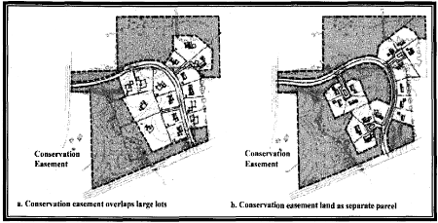
Figure IV, 3 Conservation Easement Alternative Configurations
(3)
Notations on final subdivision plat. Preserved open space land shall be clearly delineated and labeled on the subdivision final plat as to its use, ownership, management, method of preservation, and the rights, if any, of the owners of lots in the subdivision and the public to the open space land. The final plat shall clearly show that the open space land is permanently preserved for conservation purposes by a conservation easement required by this section, and shall include deed recording information in the County Clerk's office for the conservation easement.
(4)
Ownership of open space land.
(a)
Open space land shall under all circumstances be protected by a perpetual conservation easement, but may be owned in common by an HOA, offered for dedication to City, county, or state governments, transferred to a nonprofit organization acceptable to the Board, held in private ownership, or held in such other form of ownership as the Board finds appropriate to properly manage the open space land and to protect its conservation value.
(b)
If the land is owned in common by an HOA, such HOA shall be established in accordance with the following:
[1]
The HOA must be established before the approved subdivision final plat is signed, and must comply with all applicable provisions of the General Business Law.
[2]
Membership must be mandatory for each lot owner, who must be required by recorded covenants and restrictions to pay fees to the HOA for taxes, insurance, and maintenance of common open space, private roads, and other common facilities.
[3]
The HOA must be responsible for liability insurance, property taxes, and the maintenance of recreational and other facilities and private roads.
[4]
Property owners must pay their pro rate share of the costs in Article IV, Section 1, Paragraph C. 4., and the assessment levied by the HOA must be able to become a lien on the property.
[5]
The HOA must be able to adjust the assessment to meet changed needs.
[6]
The applicant shall make a conditional offer of dedication to the City, binding upon the HOA, for all open space to be conveyed to the HOA. Such offer may be accepted by the City, at the discretion of the City Council, upon the failure of the HOA to take title to the open space from the applicant or other current owner, upon dissolution of the association at any future time, or upon failure of the HOA to fulfill its maintenance obligations hereunder or to pay its real property taxes.
[7]
Ownership shall be structured in such a manner that real property taxing authorities can satisfy property tax claims against the open space lands by proceeding against individual owners in the HOA and the dwelling units they each own.
[8]
The City Attorney's Office shall find that the HOA documents presented satisfy the conditions in Subsections B(2)(a) through (g) above, and such other conditions as the Board shall deem necessary.
D.
Rural design and siting standards. The following guidelines should be considered in the process of designing and siting uses in the Rural Residential and Suburban Residential-1 Districts. When locating new uses on the land there are many options in the siting, configuration, size and arrangement of elements in the landscape. These choices define the character of the developed landscape environment. These guidelines are examples of the preferred way to design and site uses but they should not be considered the only acceptable solution.
(1)
Four basic elements establish the character of a development. These basic elements are:
(a)
Landform. Landform encompasses gradient, slope form and orientation of development in relationship to the shape of the land. Landform is the signature element that is essential for achieving an environment that has its own identity or "sense of place."
[1]
In the RR and SR-1 Districts, locally distinct natural landform features should generally be left in a natural state.
[2]
Natural rural landforms are typically soft and roll due to the rounding effect of wind and water over time. Geometric landforms may also be present in areas of shallow bedrock or seasonal flooding. The character and diversity of the natural landform should be reflected in grading to accommodate development.
[3]
Minimize cuts and fills. When grading is necessary, slopes should be graded to mimic existing slopes and blend smoothly into the surrounding landform. Graded slopes should be a maximum of 1:5 and gradually blend into surrounding slopes.
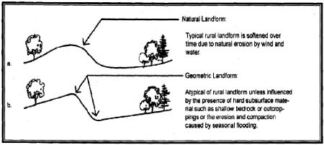
Figure IV, 4 Landform Character
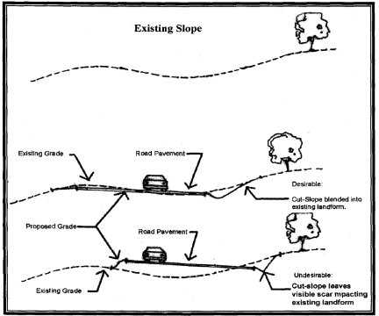
Figure VI, 5 Blending Grading Into Existing Landform
[4]
New development should not erase landforms that are indigenous to the area. Instead solutions should reflect and reinforce the area's own topographic features.
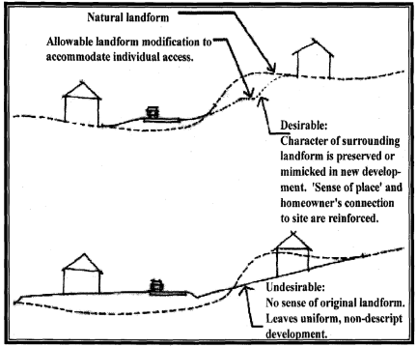
Figure IV, 6 Landform Preservation
(b)
Vegetation. Vegetation encompasses review of varying plant forms and their relationship to development and its mass on the landscape. In addition to the benefits plants offer the ecological system (soil stabilization, clean air, wildlife habitat) their presence or absence, how they are configured or arranged, and their species has a significant influence on development character. Every effort should be made to:
[1]
Preserve existing vegetation patterns and species mix and density.
[2]
Select and place new vegetation in ways that enhance the rural indigenous vegetation characteristics.
[3]
Vegetation in undeveloped rural areas is typically clustered. Rural vegetation should not be in geometric patterns that are associated with the urban environment.
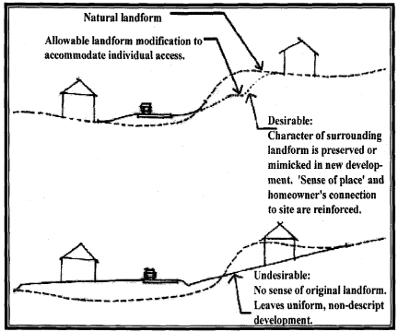
Figure IV, 7 Vegetation Types and Patterns
[4]
In the rural environment vegetation, not structures, is the primary determinant of how far we can see and where we look.
[5]
Use existing vegetation and topography to screen new buildings if possible.
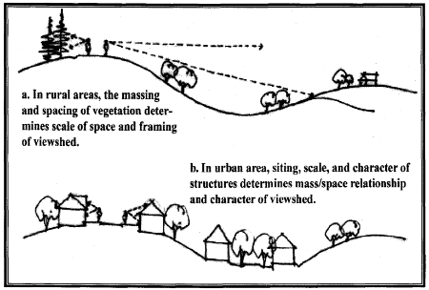
Figure IV, 8 Framing Views
(c)
Structures. The height, placement, forms and patterns of building envelopes can establish an urban or rural character to any development. The intent of this section is to identify building envelopes, forms and patterns that are complementary to and reflective of rural characteristics.
[1]
Building envelopes in rural areas should be designed to maximize the preservation of the site's natural features (e.g., landform, vegetation), whereas, in more urban environments, sites are more often modified to accommodate the building.
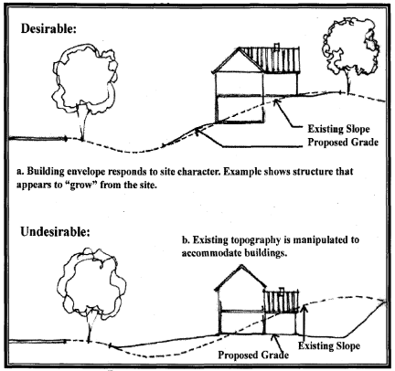
Figure IV, 9 Siting of Structures
[2]
The placement of building envelopes in relationship to streets and highways critically affects the character of a community. Varied setbacks provide a different experience than a street where buildings are placed uniformly along a street. Rural placement is historically deeper and more varied than in urban environments and therefore recommended.
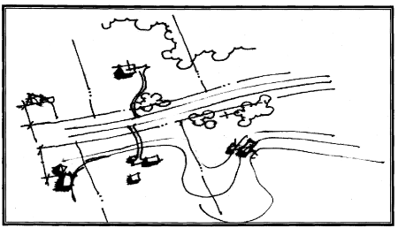
Figure IV, 10 Rural Road with Varied Setbacks
[3]
When building envelopes must be placed in open fields they should be oriented to and reflect the alignment and orientation of the site's natural features.
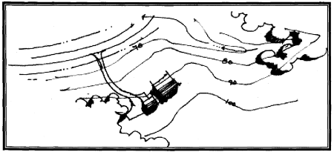
Figure IV, 11 Orient Structures to Align with Topographic Character of Land
[4]
Site building envelops so that treetops and crest lines of hills as seen from public places and roads will screen future buildings. Use vegetation as a backdrop to reduce the prominence of the structure. Wherever possible, open up views by selective cutting of small trees and pruning lower branches of large trees, rather than by clearing large areas or removing mature trees.
[5]
Group building envelopes in clusters or tuck them behind tree lines or knolls rather than spreading them out across the landscape in a "sprawl" pattern.
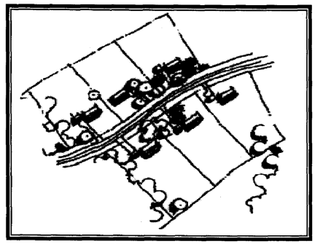
Figure IV, 12a Neighborhood Cluster
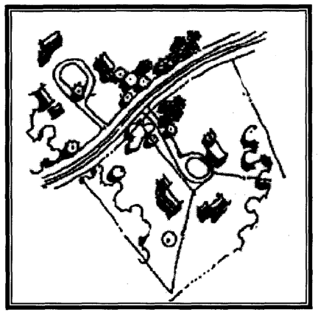
Figure IV, 12b Hamlet Cluster
[6]
The dominant visual context from the rural roads should be of natural and agricultural features, with structures visually subservient. Typically development should be interior lot development with 70% of the immediate highway view shed preserved.
[7]
The following structural guidelines apply only to structures in conservation subdivisions, which are also located in architectural review districts. The intent in these areas is to have the mass and roof forms of structures contribute to the rural character of the development. These guidelines are examples of the preferred way to design and site uses but they should not considered the only acceptable solution.
[a]
Massing of structures or structural elements influences rural character. Historically, rural buildings were often an assemblage of additions. These additions over time created a complexity of roof forms that have become icons associated with our rural agrarian environments.
[b]
Rural roof form options include, but are not limited to, symmetrically pitched or hip roofs with or without gables and horse barn-type roof ends.
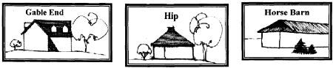
Figure IV, 13 Roof Forms
(d)
Circulation systems. Circulation systems are comprised of both vehicular and pedestrian systems. In general, rural vehicular and pedestrian systems are curvilinear in alignment, a pattern that evolved out of historic systems following the lines of least resistance (e.g., stream corridors) following natural landforms. It is only in more urbanized conditions that roads and streets should take on geometric forms reflecting the built environments they move through.
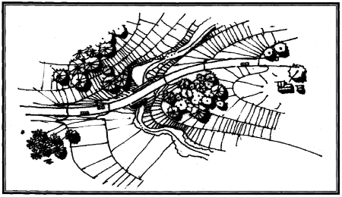
Figure IV, 14 Curvilinear road alignments are created by following the line of least topographic resistance
[1]
Whenever possible, roads (and the resultant lot layout) should be planned and designed so the site's cultural and environmental features are preserved and enhanced.
[2]
Vehicular and pedestrian circulation systems should retain and reuse historic farm roads and lanes. This guideline allows a development to build upon the site's historic context while minimizing clearing and disruption of the landscape. Care should be taken to apply this guideline only where its implementation would not destroy the historic lanes, hedgerows and stonewalls it was meant to preserve.
[3]
Otherwise, vehicular and pedestrian circulation systems should be arranged to reflect the patterns of the site landform, vegetation, water bodies and vegetation massing.
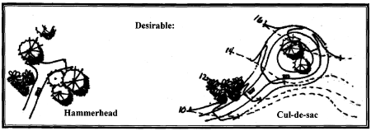
Figure IV, 15a Subdivision Roads: Form responds to and enhances natural rural character. Features such as streams, vegetation and landform are incorporated into the design.
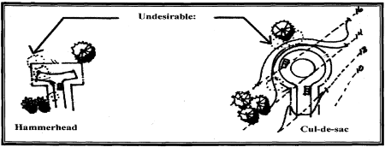
Figure IV, 15b Subdivision Roads: Design using arbitrary geometric forms that require the removal of existing vegetation and dramatic alteration of site character and/or topography.
[4]
Minimize clearing of vegetation at the edge of the road, clearing only as much as is necessary to create a driveway entrance with adequate sight distance. Use curves in the driveway to increase the screening of buildings.
[5]
Rural road edges are historically unprotected (e.g., no curbs or gutters, with only a shoulder for user safety).
[6]
Trail systems connecting destination areas should be comprised of flexible materials (e.g., asphalt, stone dust, bark) and connect areas of concentrated development.
[7]
Trails should be informal in nature and occur in rear yards.
[8]
Sidewalks should only be used to connect facilities within areas of concentrated development.

